**Task#1:** Create an application which can take user-id and password from user, and if the credentials are valid then it shows “Login successful”, otherwise it shows “login failure” message.

Your application must have following two activities:

1. **LoginActivity**

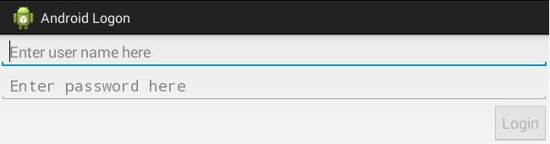

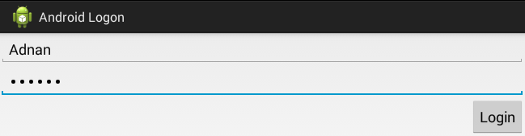

* Depending upon the user input, Login button must be enabled/disabled. You may use [*TextWatcher*](https://developer.android.com/reference/android/text/TextWatcher.html) interface with *addTextChangedListener()*
* When user pressed Login button user id and password must be passed to the ***SummaryActivity*** for authentication.

**Solution:**

**XML:**

<?xml version="1.0" encoding="utf-8"?>  
<RelativeLayout xmlns:android="http://schemas.android.com/apk/res/android"  
  
 xmlns:tools="http://schemas.android.com/tools"  
 android:layout_width="match_parent"  
 android:layout_height="match_parent"  
 tools:context=".MainActivity">  
  
 <LinearLayout  
 android:layout_width="match_parent"  
 android:layout_height="match_parent"  
 android:weightSum="10"  
 android:orientation="vertical">  
  
 <TextView  
 android:id="@+id/title_text_view"  
 android:layout_width="match_parent"  
 android:layout_height="wrap_content"  
 android:text="Sign In"  
 android:textSize="40dp"  
 android:textAppearance="?android:textAppearanceLarge"  
 android:textStyle="bold"  
 android:textAlignment="center"/>  
 <TextView  
 android:layout_width="match_parent"  
 android:layout_height="wrap_content"  
 android:layout_weight="0.5"  
 android:text="(Using Intent)"  
 android:textAlignment="center"  
 android:textSize="20dp"/>  
 <TextView  
 android:layout_width="match_parent"  
 android:layout_height="wrap_content"  
 android:layout_weight="2"/>  
  
 <EditText  
 android:id="@+id/username"  
 android:layout_width="match_parent"  
 android:layout_height="wrap_content"  
 android:hint="Username"  
 android:textSize="20dp"  
 />  
 <EditText  
 android:id="@+id/password"  
 android:layout_width="match_parent"  
 android:layout_height="wrap_content"  
 android:hint="Password"  
 android:textSize="20dp"  
 android:inputType="textPassword"  
 />  
 <Button  
 android:id="@+id/login_button"  
 android:layout_width="wrap_content"  
 android:layout_height="wrap_content"  
 android:textAlignment="center"  
 android:layout_gravity="center"  
 android:textSize="20dp"  
 android:onClick="movepage"  
 android:text="Login" />  
  
 <TextView  
  
 android:layout_width="match_parent"  
 android:layout_height="wrap_content"  
 android:text="Khizar Hayat"  
 android:textSize="20dp"  
 android:textAppearance="?android:textAppearanceLarge"  
 android:textStyle="bold"  
 android:gravity="center"  
 android:textAlignment="center"  
 android:layout_weight="4"/>  
   
 </LinearLayout>  
  
</RelativeLayout>

**JAVA:**

public class MainActivity extends AppCompatActivity {  
  
 EditText user,pass;  
 Button login;  
  
  
 @Override  
 protected void onCreate(Bundle savedInstanceState) {  
 super.onCreate(savedInstanceState);  
 setContentView(R.layout.activity_main);  
   
 user= findViewById(R.id.username);  
 pass= findViewById(R.id.password);  
 login= findViewById(R.id.login_button);  
 }  
   
 public void movepage(View v)  
 {  
 String strname = user.getText().toString();  
 String strpass = pass.getText().toString();  
  
 Intent in = new Intent(MainActivity.this,Summary.class);  
 Bundle bundle = new Bundle();  
 bundle.putString("username", strname);  
 bundle.putString("password", strpass);  
 in.putExtras(bundle);  
 startActivity(in);  
   
 }  
}

**Output:**

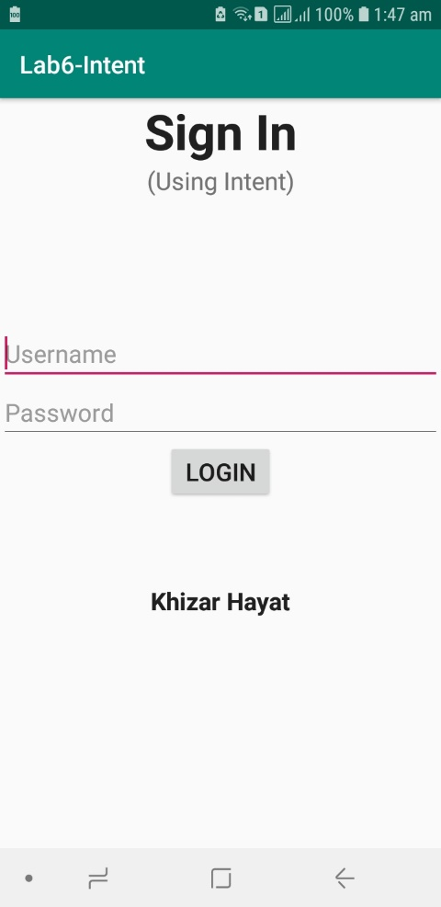

**Task#2:**

1. **SummaryActivity**

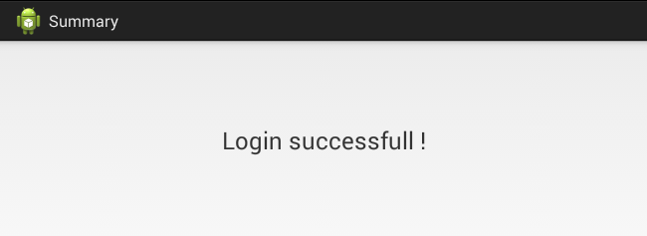

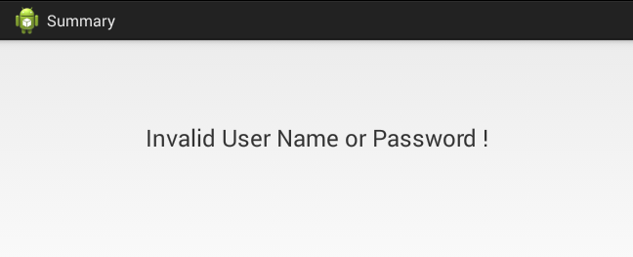

* Depending upon the credentials provided to this activity, appropriate message must be appeared.

**Solution:**

**XML:**

<?xml version="1.0" encoding="utf-8"?>  
<RelativeLayout xmlns:android="http://schemas.android.com/apk/res/android"  
  
 xmlns:tools="http://schemas.android.com/tools"  
 android:layout_width="match_parent"  
 android:layout_height="match_parent"  
 tools:context=".MainActivity">  
  
 <LinearLayout  
 android:layout_width="match_parent"  
 android:layout_height="match_parent"  
 android:weightSum="10"  
 android:orientation="vertical">  
  
 <TextView  
 android:id="@+id/title_text_view"  
 android:layout_width="match_parent"  
 android:layout_height="wrap_content"  
 android:text="Summary"  
 android:textSize="40dp"  
 android:textAppearance="?android:textAppearanceLarge"  
 android:textStyle="bold"  
 android:textAlignment="center"/>  
 <TextView  
 android:layout_width="match_parent"  
 android:layout_height="wrap_content"  
 android:layout_weight="0.5"  
 android:text="(Login Result)"  
 android:textAlignment="center"  
 android:textSize="20dp"/>  
 <TextView  
 android:layout_width="match_parent"  
 android:layout_height="wrap_content"  
 android:layout_weight="2"/>  
 <TextView  
 android:id="@+id/text_result1"  
 android:layout_width="match_parent"  
 android:layout_height="wrap_content"  
 android:text=""  
 android:textSize="40dp"  
 android:textAppearance="?android:textAppearanceLarge"  
 android:textStyle="bold"  
 android:textAlignment="center"/>  
 <TextView  
 android:id="@+id/text_result2"  
 android:layout_width="match_parent"  
 android:layout_height="wrap_content"  
 android:text=""  
 android:textSize="40dp"  
 android:textAppearance="?android:textAppearanceLarge"  
 android:textStyle="bold"  
 android:textAlignment="center"/>  
  
 </LinearLayout>  
  
</RelativeLayout>

**JAVA:**

public class Summary extends AppCompatActivity {  
TextView text1, text2;  
  
  
 @Override  
 protected void onCreate(Bundle savedInstanceState) {  
 super.onCreate(savedInstanceState);  
 setContentView(R.layout.*activity_summary*);  
  
 text1 = (TextView)findViewById(R.id.*text_result1*);  
 text2 = (TextView)findViewById(R.id.*text_result2*);  
 Bundle bundle = getIntent().getExtras();  
 String data1 = bundle.getString("username");  
 String data2 = bundle.getString("password");  
  
  
 if (data1.equals("Khizar") && data2.equals("43703")){  
 text1.setText("Login Sucessful!");  
 }  
 else {  
 text1.setText("Invaid Username and Password!");  
 }  
 }  
}

**Output:**

